Assignment Code: DS-AG-005

Statistics Basics| Assignment
Instructions: Carefully read each question. Use Google Docs, Microsoft Word, or a similar tool to create a document where you type out each question along with its answer. Save the document as a PDF, and then upload it to the LMS. Please do not zip or archive the files before uploading them. Each question carries 20 marks.

Total Marks: 200
Question 1: What is the difference between descriptive statistics and inferential statistics? Explain with examples.
Answer:

Descriptive:
- It consists of organizing and summerizing the complete data.
- Suppose we have small data.
- To describe the exact data.
- It is used to calculate whole data
- Here are some techniques:
    - Measure of central tendency (Mean, Median, Mode)
    - Measure of dispersion (standard deviation, variance)
    - Measure of symmetricity (skewness, kurtosis)
- Talks about complete population.
- Example: I want to find out how many students in my class.
I can count whatever I see. And get exact number.

Inferential:
- It consists of using sample data that has been measured to form conclusion about a data.
- Suppose we have large data, if we have time and resource constraint, we can get to know about the whole data based on conclusion
- To give inference (conclusion)
- It is used to calculate sample data.
- Here are some techniques:
  - Probability Distribution Function: pmf, pdf, cdf
  - Statistical test: z-test, t-test, chi-square test, Anova-test(f-test).
- Talks about sample(conclusion) which gives probability of or chances of how much population would be there. Sample(conclusion) made for to calculate complete population.
- Example: I want to find out how many hairs in my head.
  - I just take sample (count whatever I see which is average) and predict or
  - based on that conclusion. I get to know.

Question 2: What is sampling in statistics? Explain the differences between random and stratified sampling.
Answer:
First why sampling occur: There is Inferential data
In inferential Statistics when we have large data population and we need more time and resource constraint. We can calculate the population.
But in some cases, we won’t be able to calculate. To calculating this is known as Sampling.

Explain the differences between random and stratified sampling.
Suppose there is some cases: To check the Farmer’s crop.
We just take some sample. And check it.

if we mix some seeds: Amaranthus leaves-10 seeds, spinach-5 seeds, green sorrel-2 seeds.
And we want to check quality for that.

Sample random Sampling:
- Every seed of the vegetables(N) has an equal chance of being selected in the sample. Each seed has1/3 probability or chance of being selected in the sample.

- A less possibility of seeds not being part of sample from a certain group.

- In sample random sampling: The seeds of green sorrel in Vegetables might have lesser strength. It might be ignored.

- There is no group of same seed. It might be taken for sample randomly.

Stratified sampling:
- In Stratified sampling there is different distinct categories. A Sample random sampling would be chosen from each strata/group/category.

- A high possibility of seeds being part of sample from a certain group.

- In stratified sampling: The seeds of green sorrel in Vegetables might have lesser strength. It must be selected.

- There is a group of same seed. It must be taken for sample randomly from every strata.

Question 3: Define mean, median, and mode. Explain why these measures of central tendency are important.
Answer:
Data=3,2,7,8,100

Mean: Mean is the Arithmetic midpoint value. Mean mostly used in Numerical (Continuous) data. When in some data there is null values (Nan).
Use: For creating model, we need to remove/replace/imputation using Mean/Median of the data. Mean affected by outlier.

Sum of every all observation
Mean=
No. of observation

3+2+7+8+100
Mean=
5
Mean=24

Median: Median is the middle most value. Median mostly used in Numerical (Continuous) data. When in some data there is null values (Nan).
Use: For creating model or unique values we need to remove/replace/imputation using Mean/Median of the data. Median is not associated with Arithmetic. Median is not affected by outlier.

Sort the Data: 2,3,7,8,100
- Even: Median=take both middle values, sum of both and divide by 2. We got median.
- Odd: just take middle most element.
Median=7

Mode: Mode is the Highest frequency in the data is known as mode. The mode is also used for Categorical Data where we need Imputation.

Data=3,2,2,7,8,100

Mode=2

Question 4: Explain skewness and kurtosis. What does a positive skew imply about the data?
Answer:
Skewness measures the asymmetry of a data distribution.
- Zero skewness → the data is symmetric.
- Positive skewness → the distribution has a long tail on the right.
- Negative skewness → the distribution has a long tail on the left.
Kurtosis
Kurtosis describes the peaked Ness or flatness of a distribution and the presence of extreme values (outliers).
- High kurtosis → a sharp peak and more extreme values.
- Low kurtosis → a flatter distribution with fewer extremes.

Positive skew implies that most data values are relatively low, with a few very high values stretching the distribution to the right.

Question 5: Implement a Python program to compute the mean, median, and mode of a given list of numbers.

numbers = [12, 15, 12, 18, 19, 12, 20, 22, 19, 19, 24, 24, 24, 26, 28]

(Include your Python code and output in the code box below.)
Answer:
Paste your code and output inside the box below:
numbers = [12, 15, 12, 18, 19, 12, 20, 22, 19, 19, 24, 24, 24, 26, 28]

import numpy as np
import statistics

np.mean(numbers)
19.6

np.median(numbers)
19

statistics.mode(numbers)
12

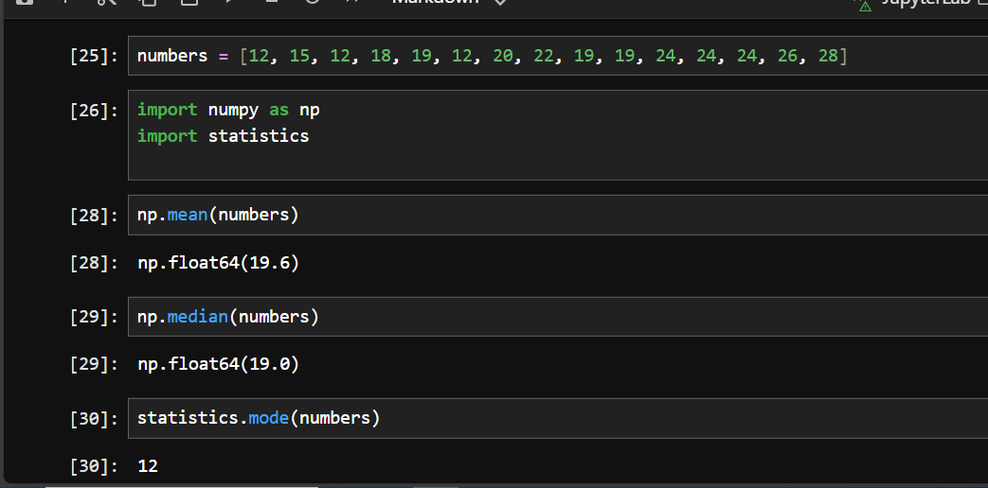

Question 6: Compute the covariance and correlation coefficient between the following two datasets provided as lists in Python:

list_x = [10, 20, 30, 40, 50]
list_y = [15, 25, 35, 45, 60]

(Include your Python code and output in the code box below.)
Answer:
Paste your code and output inside the box below:
x = [10, 20, 30, 40, 50]
y = [15, 25, 35, 45, 60]

import numpy as np
import pandas as pd

df=pd.DataFrame({
"x":x,
"y":y
})

df

np.mean(x)
np.mean(y)

df.cov()

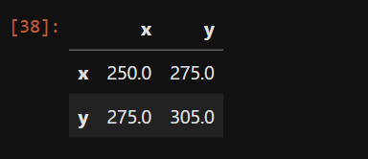

df.corr()

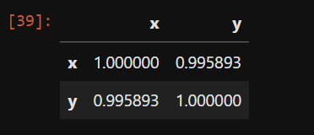

Correlation range between -1 to 1.

sns.lineplot(df)

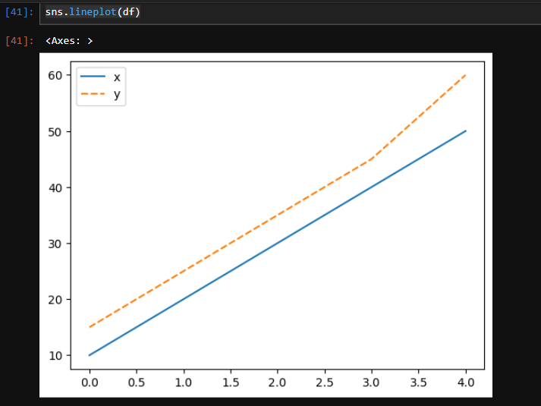

Covariance tells us if both variable increases then its accurate covariance.
Value is positively correlate.
Question 7: Write a Python script to draw a boxplot for the following numeric list and identify its outliers. Explain the result:

data = [12, 14, 14, 15, 18, 19, 19, 21, 22, 22, 23, 23, 24, 26, 29, 35]

(Include your Python code and output in the code box below.)
Answer:
data = [12, 14, 14, 15, 18, 19, 19, 21, 22, 22, 23, 23, 24, 26, 29, 35]

# range
ran=max(data)-min(data)
ran

# percentile
import numpy as np
percen=np.percentile(data,[0,25,50,75,100])
percen

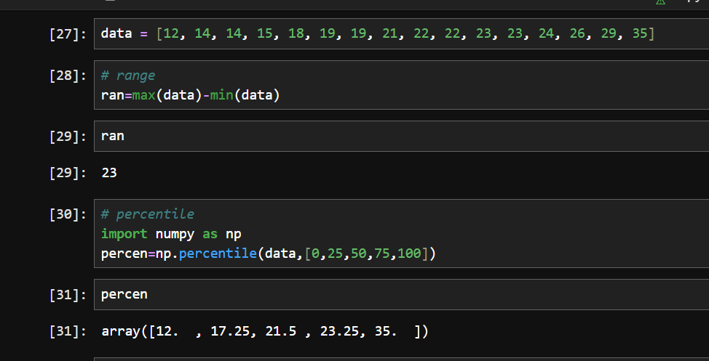

# iqr
i=percen[3]-percen[1]
i

uf=percen[3]+1.5*i
uf

lf=percen[1]-1.5*i
lf

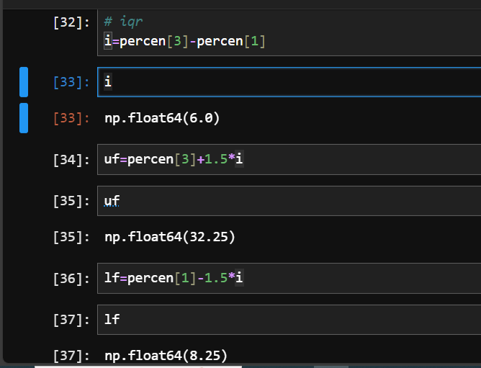

np.std(data)

np.var(data)

from scipy.stats import skew
skew(data)

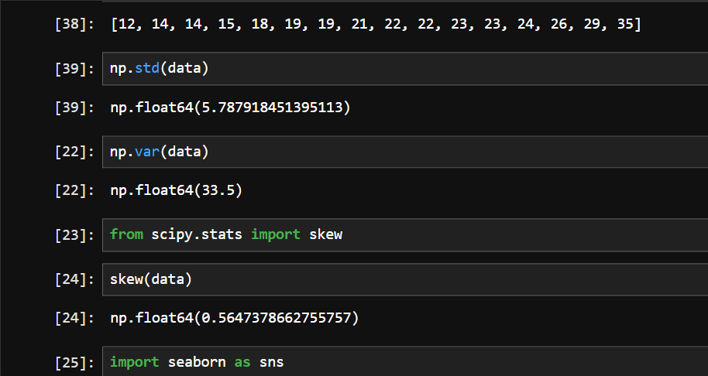

import seaborn as sns
sns.boxplot(data)

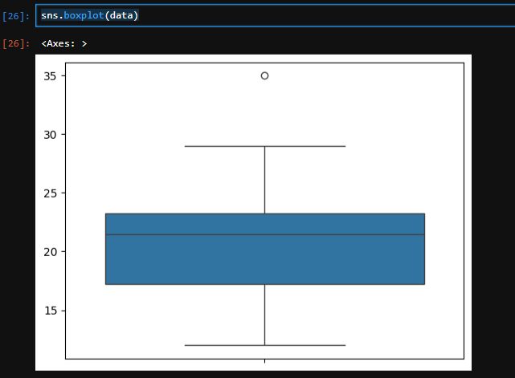
Question 8: You are working as a data analyst in an e-commerce company. The marketing team wants to know if there is a relationship between advertising spend and daily sales.
- Explain how you would use covariance and correlation to explore this relationship.
- Write Python code to compute the correlation between the two lists:
advertising_spend = [200, 250, 300, 400, 500]
daily_sales = [2200, 2450, 2750, 3200, 4000]
(Include your Python code and output in the code box below.) Answer:
advertising_spend = [200, 250, 300, 400, 500]
daily_sales = [2200, 2450, 2750, 3200, 4000]

df=pd.DataFrame({
"advertising_spend":advertising_spend,
"daily_sales":daily_sales
})
df

df.cov()
df.corr()

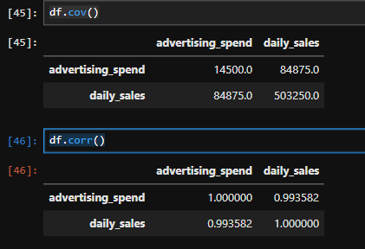
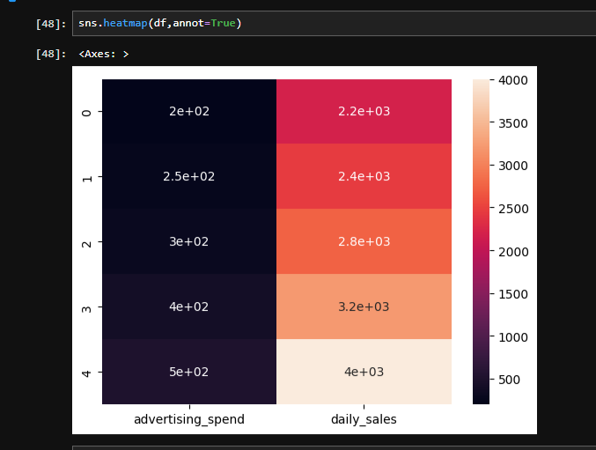

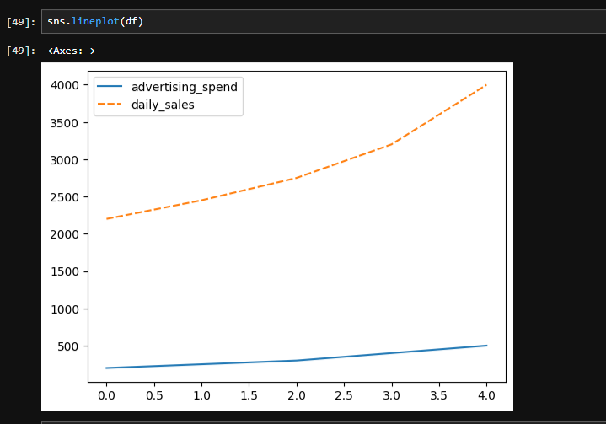

I observed that advertising spend increases from 200 to 500, and daily sales increase from 2200 to 4000.
The covariance is positive, meaning both variables move together.
The correlation is 0.99, which indicates a very strong positive relationship.
This means higher advertising spend is strongly associated with higher daily sales.”

Question 9: Your team has collected customer satisfaction survey data on a scale of 1-10 and wants to understand its distribution before launching a new product.
- Explain which summary statistics and visualizations (e.g. mean, standard deviation, histogram) you’d use.
- Write Python code to create a histogram using Matplotlib for the survey data:
survey_scores = [7, 8, 5, 9, 6, 7, 8, 9, 10, 4, 7, 6, 9, 8, 7] (Include your Python code and output in the code box below.)
Answer:
survey_scores = [7, 8, 5, 9, 6, 7, 8, 9, 10, 4, 7, 6, 9, 8, 7]

# mean : how much customer satisfied, we got overall idea
import numpy as np
np.mean(survey_scores)

# median : if data is skewed its useful.
np.median(survey_scores)

# mode : most common satisfaction score
import statistics
statistics.mode(survey_scores)

# std : how much customer satisfaction vary
np.std(survey_scores)

# min,max : to know the satisfaction
min(survey_scores)

max(survey_scores)

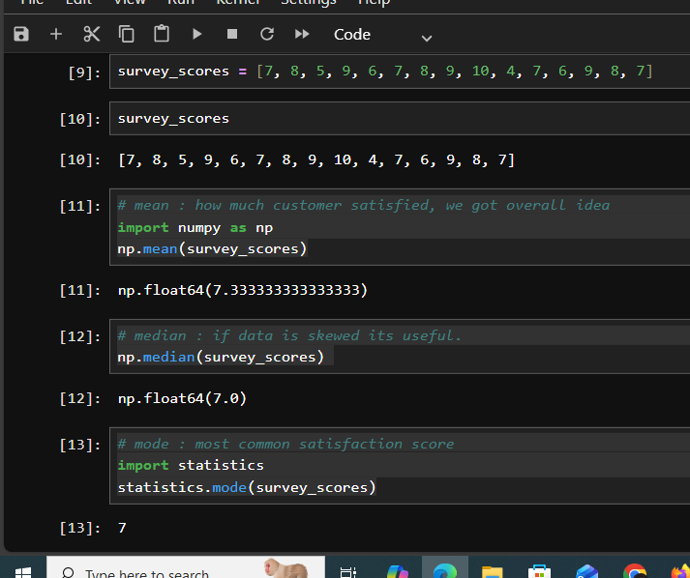

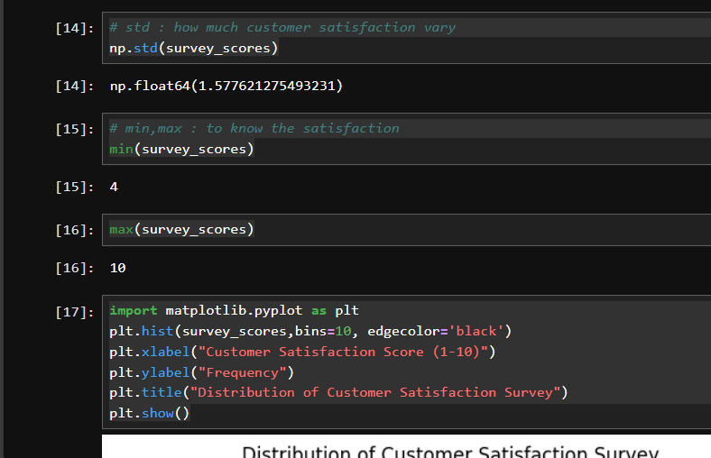

import matplotlib.pyplot as plt
plt.hist(survey_scores,bins=10, edgecolor='black')
plt.xlabel("Customer Satisfaction Score (1-10)")
plt.ylabel("Frequency")
plt.title("Distribution of Customer Satisfaction Survey")
plt.show()
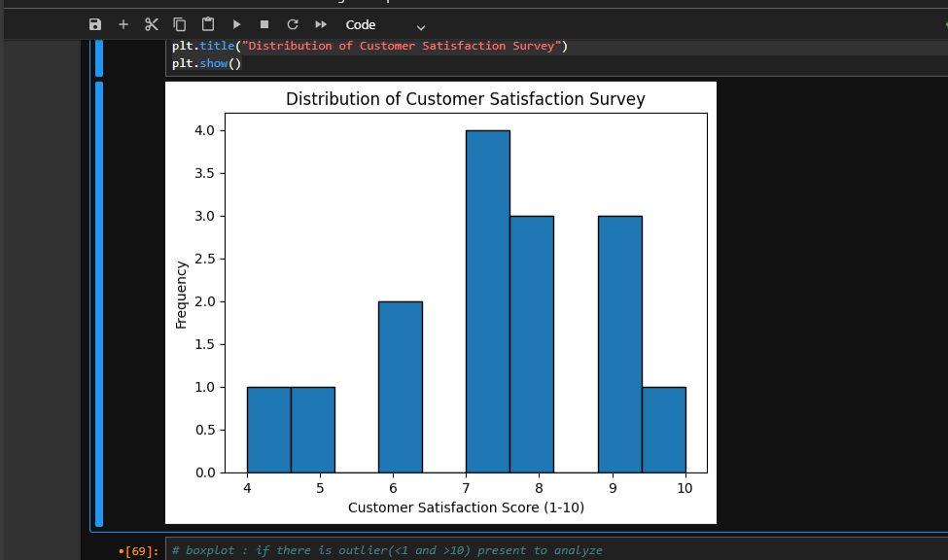

# boxplot : if there is outlier(<1 and >10) present to analyze
sns.boxplot(survey_scores)

